=

­­­­­

Gospel of Mark 7: 31-37

johnuke 24:13—35

Liturgical year (B)

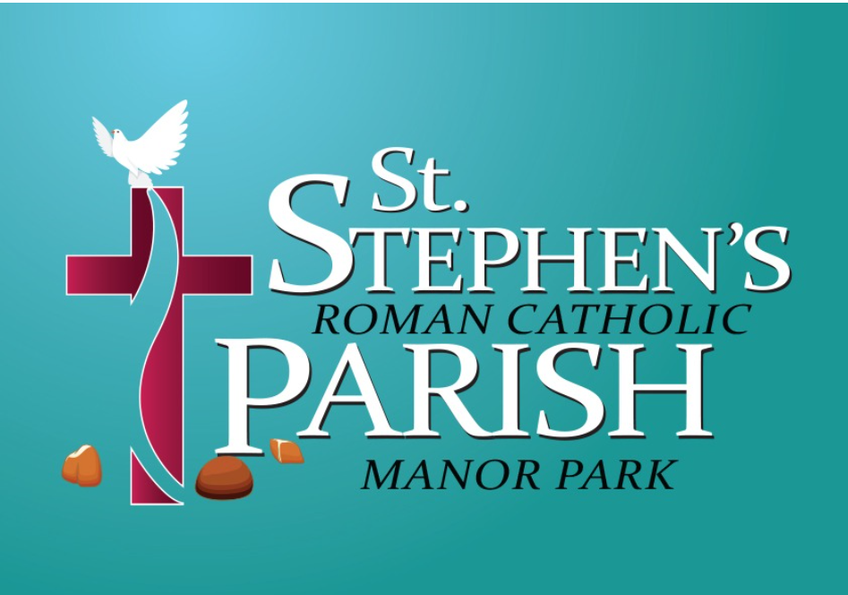

PARISH NEWSLETTER

23rd Sunday of the Year

Isaiah 35: 4-7

Psalm 145(146): 7-10

James 2: 1-5

**Welcome to St Stephen’s Catholic Church**

**Sat 4th September – Sun 12th September 2021**



Presbytery: 146 Little Ilford Lane, Manor Park, London E12 5PJ

Rev. John Victor

Clergy:





**Welcome to Father John Victor**

Father John Victor will be moving to Manor Park on Wednesday 1st September. We wish him a happy and blessed time with us in the parish.

From 2nd September, daily masses will be revived, with morning prayer at 9.00 am and mass at 9.15 am. On Sunday 5th September, mass will be celebrated as usual at 10.00 am. As of Sunday 12th September, it is planned that there will be two masses on Sunday, at 9.00 am and 11.00 am.

Mass will continue to be live-streamed during September and October, and the situation will be reviewed after that.

Facebook page**:**

**SOCIAL MEDIA HANDLES**

*@manorparkRC*

Twitter page:

*@manorparkRC*

Food Bank on Facebook & Twitter:

*@mprcfoodbank*





**Joseph and Agnes Educational Foundation**

Tina Amuzie, parishioner of St Stephens, is organising a 5 mile WALK WITH ME sponsored event to raise money for equipment for her newly opened school in Nigeria.

Date: Sunday 5th September, 11.00 am, City Island, Canning Town

Please also consider making a donation via the GoFundMe link https://gofund.me/144f465d

Registered charity number: CAC136570

St. Nicholas Chapel, Gladding Road, Manor Park, London, E12 5DD (Closed)

Belongs to St. Stephen’s Parish

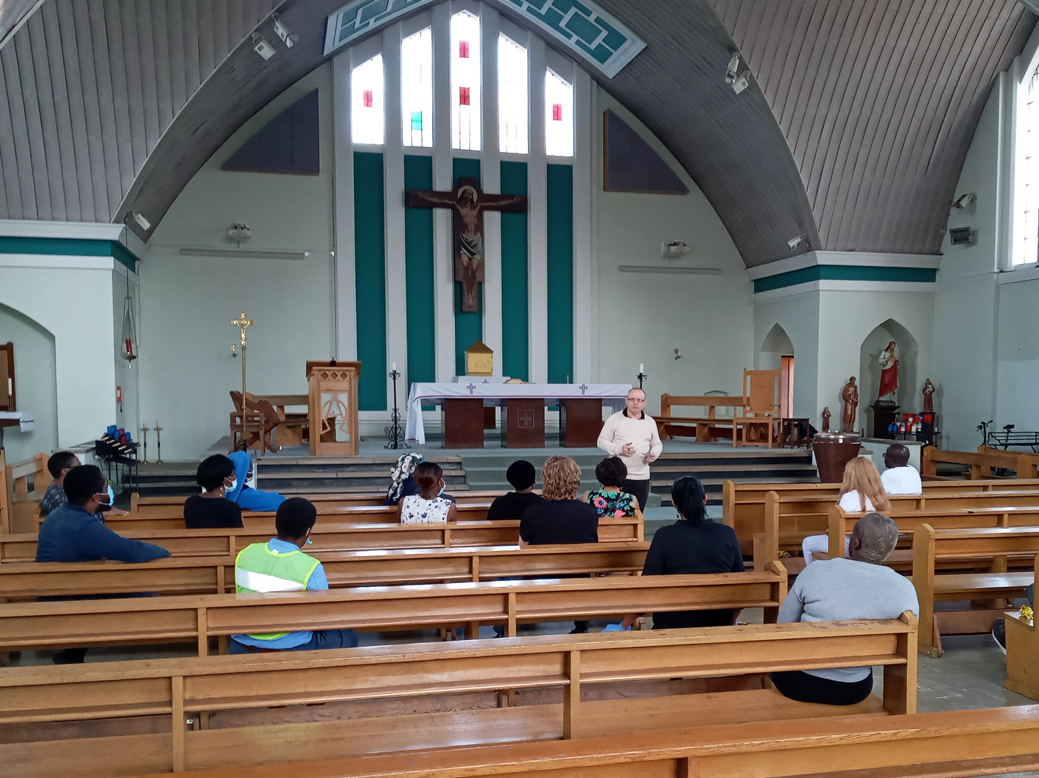

Fr John Victor will be live-streaming Mass on Sunday via the parish YouTube account. To celebrate Mass live with us, please go to St Stephens Catholic Church Manor Park on YouTube.

Everyone is invited to join in prayer on Wednesday evenings at 8.00 pm via Zoom: ID: 823 2961 0910 Passcode: 278861

**Who is the central character in the old Testament?**

|  |  |  |
| --- | --- | --- |
| Date | Times | Mass Intentions |
| Sunday 5th September 2021 | 10.00 am | May and Clarence (Bill) Treleaven RIP (F) |
| Sunday 12th September | 9.00 am  11.00 am | Mrs Gloria Alcaba RIP |

Please pray for our parishioners who are sick, especially the following:

Angela Maher

John Oruche

Veronica Ojuri

Margaret

Sheila Appleton

Chris

Loreen Phillips

Nicholas Graves

Kath Phillips

... and all who have been affected

by Covid 19.

If you or someone you know, would like to be included in the list for prayers, please contact the church office or a member of the newsletter team.

**Catholic Certificate in Religious Studies**

**“CCRS gave me such understanding and confidence about my faith for my parish work.”**

The Catholic Certificate in Religious Studies (CCRS) provides parish leaders with knowledge and understanding of theology and the Catholic faith.

88% of participants recommend the course to others.

Learn in person, by distance learning or online.

**For more information, visit brs-ccrs.org.uk .**

During this time when we are not all able to attend the parish physically we invite those that are able to make a donation to the upkeep of the parish. If you are not able to give as you are struggling financially that is fully understood.

If you wish to make a donation please go to the parish website www.ss-stephenandnicholas.org.uk and go to the Events page.

**The Bible Timeline Course 2021**

**Free of Charge/Live Streamed**

An 8 session course on Wednesdays, starting on

**Wed 29th Sept 2021 at 7.00 pm**

**Info & Registration:**

**www.comeandsee.org**

The Bible can be quite intimidating, due to its size and complexity. Many Catholics long to read the Bible, but they don’t know how.

The Bible Timeline Study System, developed by Jeff Cavins, uses a phenomenal approach which actually works! It divides the whole Bible into 12 colour-coded periods, easy to understand and memorise.

Each live-streamed session has a time of discussion with Q&A. Bible Readings and Teaching Summary Notes will be available.

*Mauro Iannicelli*

*(Come and See Catholic Evangelisation Ministries)*

**Daily Prayer – 10.00 am**

Each morning, from our own homes, we are invited to light a candle and say a prayer – knowing that our fellow parishioners will be united with us as they pray in their own homes.

Friday night 7.00 pm Rosary Zoom details: https://zoom.us/j/96047520655?pwd=RDRacWRGWnl6b0dLL0ZpM1JjWTJzQT09

Meeting ID: 96047520655

Passcode: 487330

This is a recurring meeting.